D SARATH BABU
192311031

Ethical Hacking
1. Execute and display the results for the following commands in Kali Linux Operating
Systems:
rm command
users command
tree command
Aim: To execute and study the rm, users, and tree commands in Kali Linux Operating System and observe their outputs.

1. rm Command
Commands:
touch test.txt
ls
rm test.txt
ls
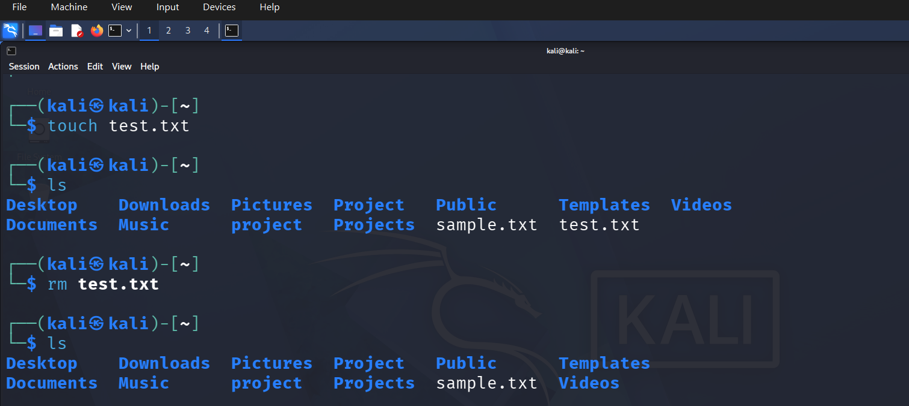
Explanation
- touch test.txt — Creates an empty file named test.txt.
- ls — Displays the files and directories in the current directory. The first ls should show test.txt.
- rm test.txt — Removes/deletes the test.txt file.
- ls — Displays the directory contents again. test.txt should no longer appear.
2. users Commands
Commands:
Users

Explanation
The users command displays the username of the user currently logged into the Kali Linux system.

3. Tree Command
Commands:
mkdir Experiment1
touch Experiment1/sample.txt
tree
rm Experiment1/sample.txt
rmdir Experiment1
tree
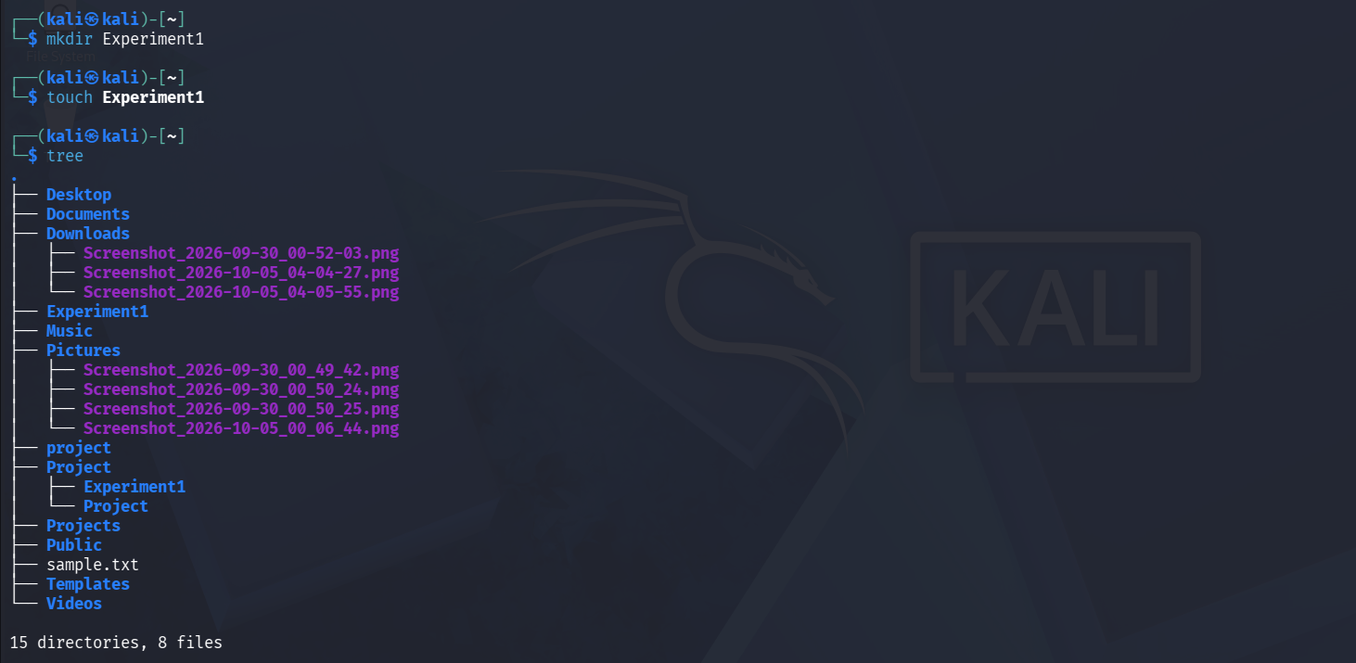
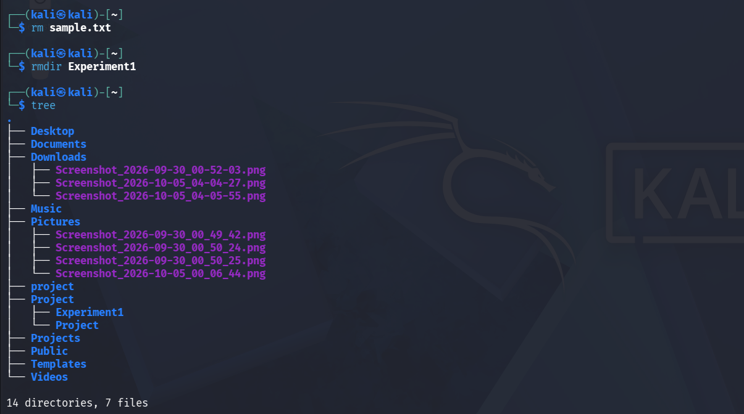

Explanation
- mkdir Experiment1 — Creates a new directory named Experiment1.
- touch Experiment1/sample.txt — Creates an empty file named sample.txt inside the Experiment1 directory.
- tree — Displays the directory and file structure in a hierarchical tree format.
- rm Experiment1/sample.txt — Removes the sample.txt file.
- rmdir Experiment1 — Removes the now-empty Experiment1 directory.
- tree — Displays the directory structure again after the directory and file have been removed.

Final Result
Thus, the rm, users, and tree commands were successfully executed in Kali Linux, and their outputs were displayed and verified.

